Logo – Increase the Niswah Boutique logo size and make it more prominent.
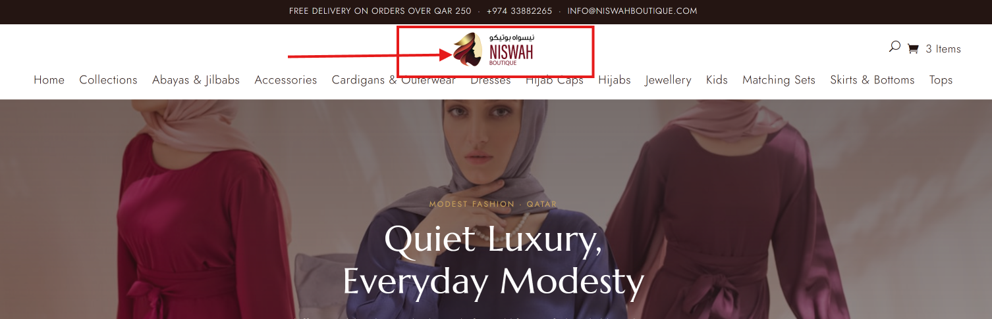
Brand Colours
Ribbon & Footer: #891109
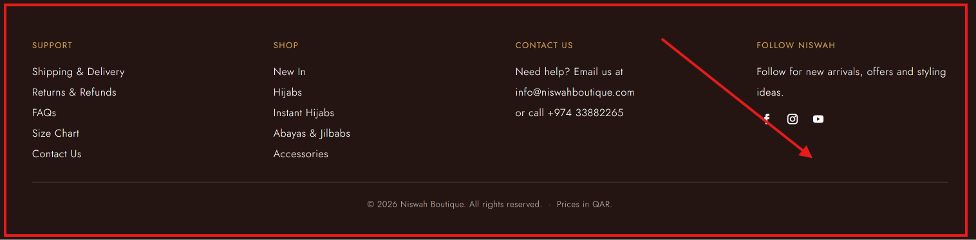
Background: #FAF2E6
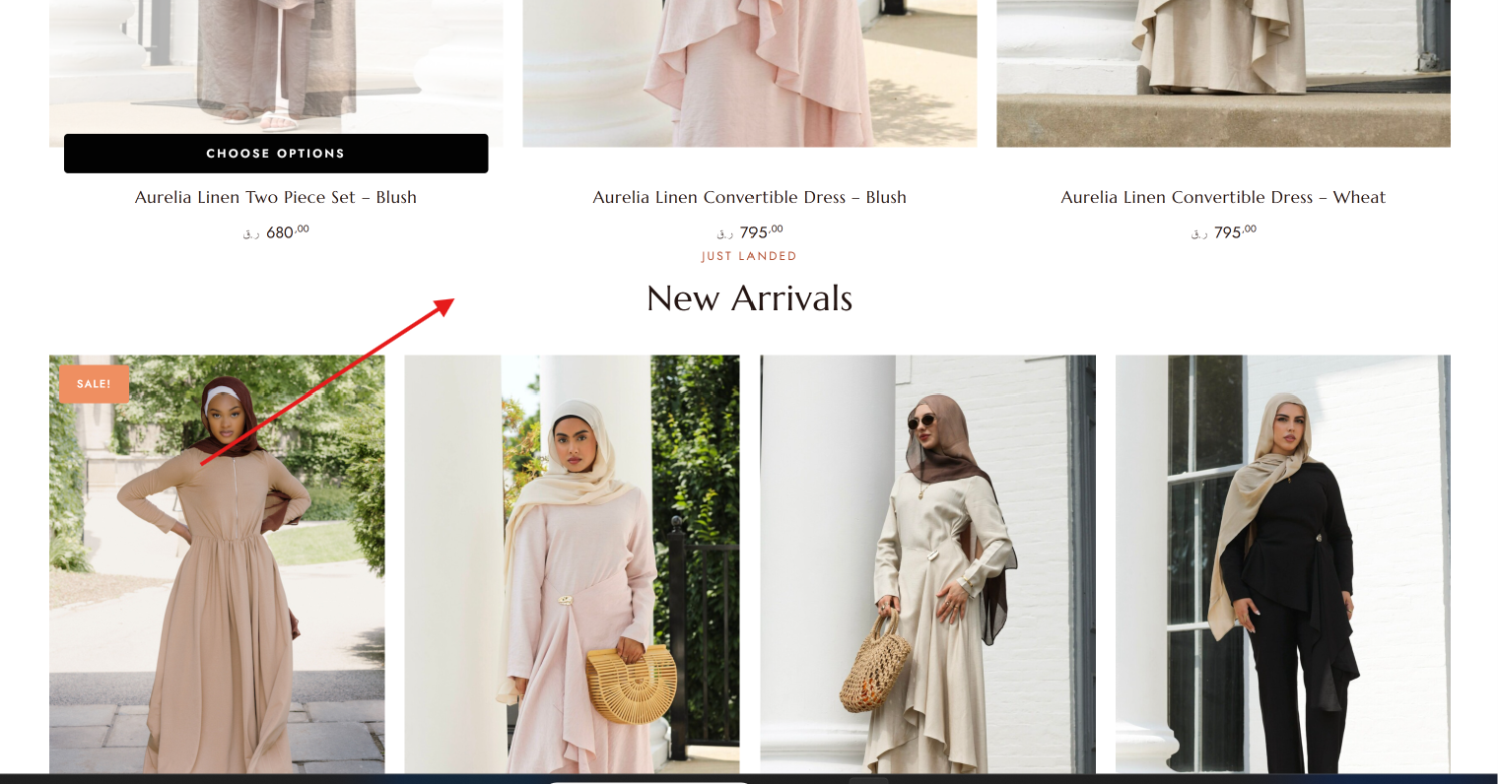

Button colour: #891109
Button font: #FAF2E6
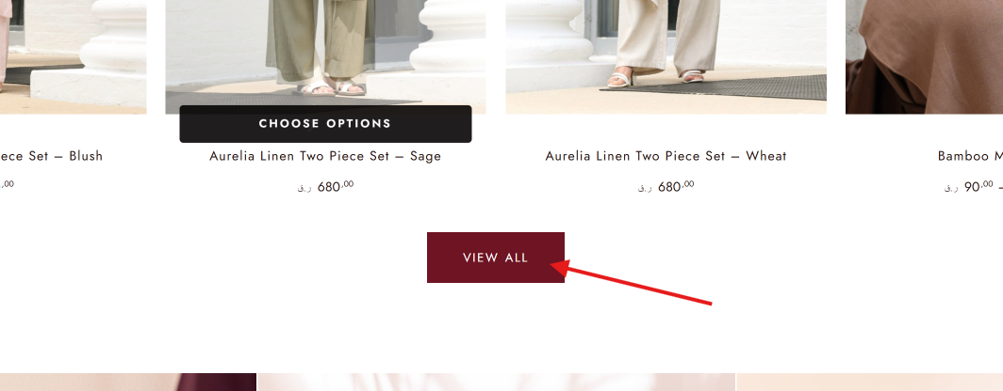

Existing font can be retained.
Product Image Ratio
Hijabs & Accessories: 1:1
Jilbab, Coord Sets, Dresses, etc.: 1:2

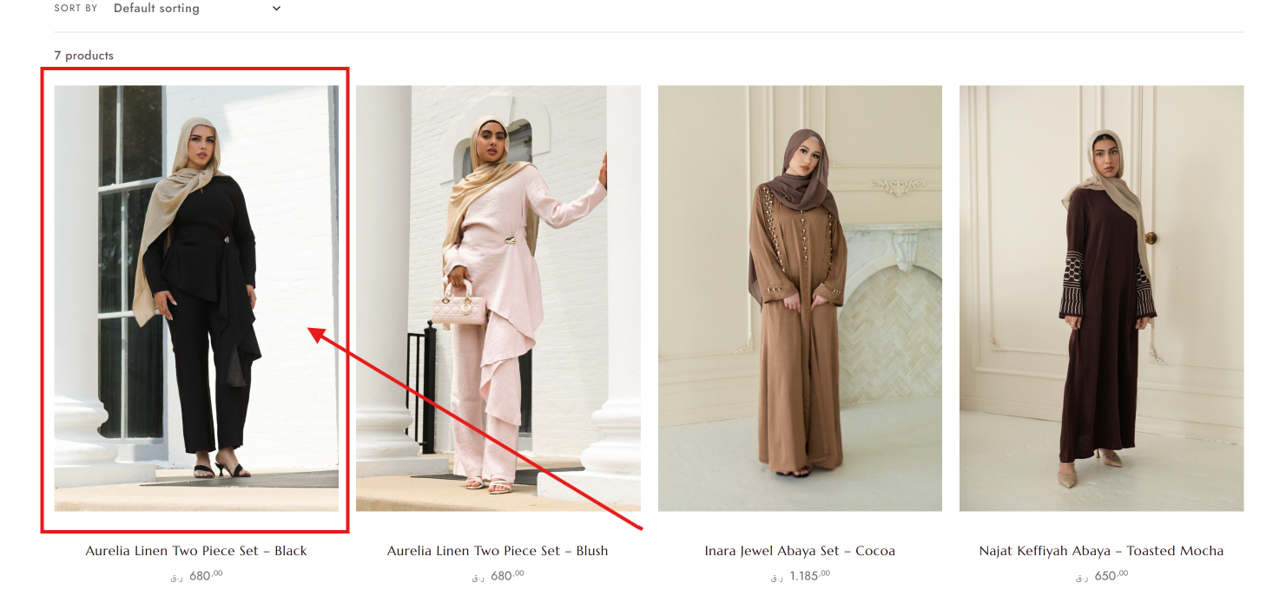

Language – English/Arabic bilingual toggle is currently not available. Please add an EN/AR language switcher accessible from the header on all pages, including product pages, cart, checkout and footer/legal pages. Arabic should have proper RTL formatting.

About Us – Add an About Niswah Boutique section/page.
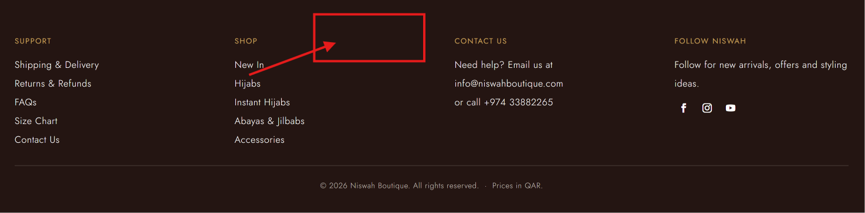
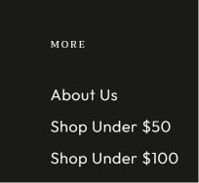

Payment Options – Display all available payment methods clearly on the website.

Social Media – Add Follow Us: @boutiqueniswah and link all previously provided social media/platform accounts.
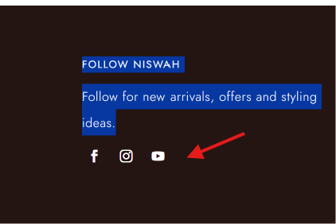

Pricing / Tax
Ensure product pricing clearly displays any VAT/tax information or disclosure required under Qatar regulations, if applicable to the business.
Checkout Address Format
The checkout address fields should follow the Qatar address / blue plate format, preferably:
Zone
Street
Building No.
Unit No. / Flat No.
Please ensure these fields are clear and easy for customers to complete.
Footer – Include About Us, Contact, Shipping & Delivery, Returns & Refunds, Privacy Policy, Terms & Conditions, Social Media and Payment Options
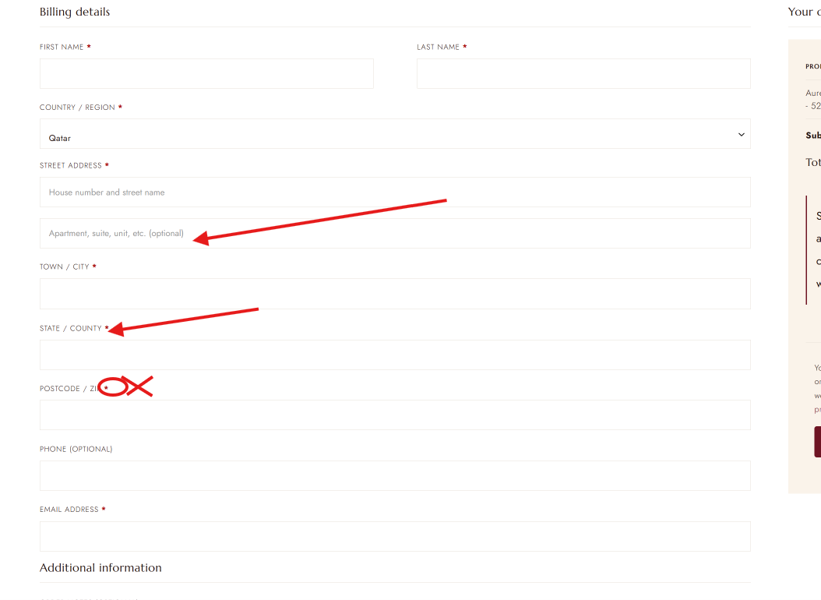

Returns & Exchanges Policy
At Niswah Boutique, we want you to be happy with your purchase. Please review the following policy before placing your order.
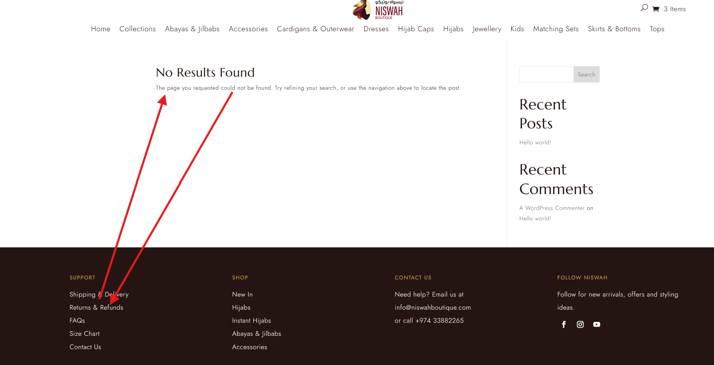
1. Returns for Change of Mind
Eligible items may be requested for return or exchange within 3 days from the date of delivery, provided that:
- The item is unused, unworn and in its original condition.
- All original tags, labels and packaging are intact.
- The item has not been washed, altered, damaged or used.
- The item is returned with the original invoice/order details.
Return or exchange requests that do not meet these conditions may be rejected.
2. Wrong, Defective or Damaged Items
If you receive an item that:
- Is different from the item you ordered;
- Does not match the description or specifications provided on the website;
- Has a manufacturing defect; or
- Was damaged before or during delivery,
please contact us as soon as possible after receiving the order.
Niswah Boutique will assess the issue and, where applicable, provide an appropriate remedy in accordance with applicable Qatar consumer protection requirements, which may include replacement, repair or refund.
For defective, damaged, incorrect or non-conforming products, Niswah Boutique will not charge the customer for the applicable return/replacement process where the issue is attributable to Niswah Boutique or the product.
Customers may be requested to provide photographs or other information to help us verify the issue.
3. Hygiene-Sensitive Products
For hygiene and health reasons, the following items are not eligible for return or exchange due to change of mind, provided they are correctly supplied, free from defects and conform to their description:
- Hijabs
- Hijab Caps / Undercaps
- Jewellery
- Accessories
- Other products identified on the product page as hygiene-sensitive
This restriction does not affect any rights the customer may have under applicable Qatar law where a product is defective, damaged, incorrect or does not conform to the agreed description or specifications.
4. Sale & Promotional Items
Sale, discounted and promotional items are generally final sale and are not eligible for return or exchange due to change of mind, unless otherwise stated on the product page.
However, this does not exclude or limit any consumer rights or remedies that apply under Qatar law where an item is defective, damaged, incorrect or does not conform to the description or agreed specifications.
5. Exchanges – Size or Colour
Where an item is eligible for exchange, customers may request an alternative available size or colour.
Exchange is subject to:
- Product availability;
- The item meeting the return conditions; and
- Applicable delivery/collection charges, where the exchange is requested due to customer preference or change of mind.
Where the exchange is required because Niswah Boutique supplied an incorrect, defective, damaged or non-conforming item, the applicable return/replacement costs will be handled by Niswah Boutique, subject to verification.
6. How to Request a Return or Exchange
Please email us at:
info@niswahboutique.com
with:
- Order number
- Customer name and contact number
- Reason for return/exchange
- Photos, where applicable
Our team will review the request and guide you through the next steps.
Please do not send any item back before receiving confirmation from Niswah Boutique.
7. Return Shipping & Delivery Charges
For customer-requested returns or exchanges due to change of mind, applicable return, collection and/or delivery charges may apply.
Where the return is due to an incorrect, defective, damaged or non-conforming product attributable to Niswah Boutique, the applicable return/replacement costs will be covered by Niswah Boutique, subject to verification.
8. Refunds
Once the returned item has been received and inspected, we will confirm whether the return qualifies for a refund.
Where a refund is approved, it will be processed through the applicable payment method, subject to the payment method used and applicable processing procedures.
- Cash on Delivery (COD): Refund may be provided through an approved refund method or Niswah Boutique credit/voucher, as applicable and agreed with the customer.
- Online/Card Payment: Refund will generally be processed through the original payment method, subject to payment gateway/bank processing times.
- Store Credit/Voucher: Where applicable, an approved refund may be issued as Niswah Boutique credit/voucher.
Any refund will be handled in accordance with applicable Qatar consumer protection requirements.
9. Important Notice
Nothing in this Returns & Exchanges Policy is intended to exclude, restrict or waive any mandatory rights or remedies available to consumers under applicable laws and regulations of the State of Qatar.
Niswah Boutique reserves the right to verify the condition and reason for any return or exchange request before approving it.
For assistance:
Email: info@niswahboutique.com
Instagram: @boutiqueniswah

